Experiment – 4
Build an Artificial Neural Network by implementing the Backpropagation algorithm and test the same using appropriate data sets.

Aim
To build an Artificial Neural Network by implementing the Backpropagation algorithm and test it using the XOR dataset.

Algorithm
- Initialize weights and biases randomly.
- Perform forward propagation.
- Calculate the error.
- Perform backpropagation to update weights and biases.
- Repeat for a fixed number of epochs.
- Test the trained network with input data.
Program:
import numpy as np
# Sigmoid activation function
def sigmoid(x):
return 1 / (1 + np.exp(-x))
# Derivative of sigmoid
def sigmoid_derivative(x):
return x * (1 - x)
# XOR Input and Output
X = np.array([[0,0],
[0,1],
[1,0],
[1,1]])
Y = np.array([[0],
[1],
[1],
[0]])
# Seed for reproducibility
np.random.seed(42)
# Network architecture
input_neurons = 2
hidden_neurons = 2
output_neurons = 1
# Initialize weights and biases
W1 = np.random.uniform(size=(input_neurons, hidden_neurons))
B1 = np.random.uniform(size=(1, hidden_neurons))
W2 = np.random.uniform(size=(hidden_neurons, output_neurons))
B2 = np.random.uniform(size=(1, output_neurons))
learning_rate = 0.5
epochs = 10000
# Training
for epoch in range(epochs):
# Forward Propagation
hidden_input = np.dot(X, W1) + B1
hidden_output = sigmoid(hidden_input)
final_input = np.dot(hidden_output, W2) + B2
predicted_output = sigmoid(final_input)
# Error
error = Y - predicted_output
# Backpropagation
d_output = error * sigmoid_derivative(predicted_output)
error_hidden = d_output.dot(W2.T)
d_hidden = error_hidden * sigmoid_derivative(hidden_output)
# Update weights and biases
W2 += hidden_output.T.dot(d_output) * learning_rate
B2 += np.sum(d_output, axis=0, keepdims=True) * learning_rate

W1 += X.T.dot(d_hidden) * learning_rate
B1 += np.sum(d_hidden, axis=0, keepdims=True) * learning_rate
# Testing
print("Predicted Output after Training:")
print(predicted_output.round(3))

Output:
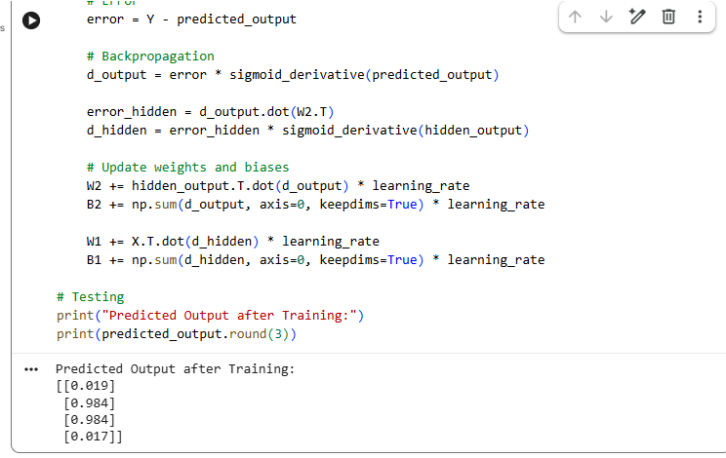

Result
The Artificial Neural Network was successfully implemented using the Backpropagation algorithm. When tested with the XOR dataset, the network correctly learned the XOR function, producing outputs close to the expected values (0 and 1). Thus, the implementation is verified successfully.

